Chef’s names _______________________________________________ period______ kitchen #_____

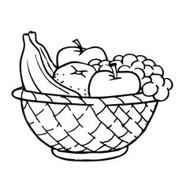__________________________________________________________

**FRUIT SMOOTHIES**

**INGREDIENTS:**

2 cups fruit of your choice

1 peeled banana

1 cup yogurt - any flavor

2 ½ cups ice cubes

1 ¼ cup milk, juice or almond milk

**DIRECTIONS:**

___all____1. Tie hair up and wash hands.

__________2. Fill sink with hot water and soap.

__________3. Get dish towel and wash cloth.

__________4. Measure fruit (not banana) and place in blender.

__________5. Peel banana and place in blender.

__________6. Measure yogurt and place in blender.

__________7. Measure milk, juice or almond milk and place in blender

__________8. Put cover on blender & turn blender on to combine fruit and yogurt.

__________9. Measure ice and place in blender.

_________10. Place cover on blender, turn on and blend until ingredients completely

blended and smooth.

_________11. Pour equally into cups.

_________12. Wash & rinse dishes.

_________13. Dry dishes & return to proper location.

_________14. Clean base of blender. Do not put in sink water.

_________15. Clean counters.

_________16. Call teacher for kitchen inspection.

*TIP- at home top with a wedge of fresh fruit and whipped cream